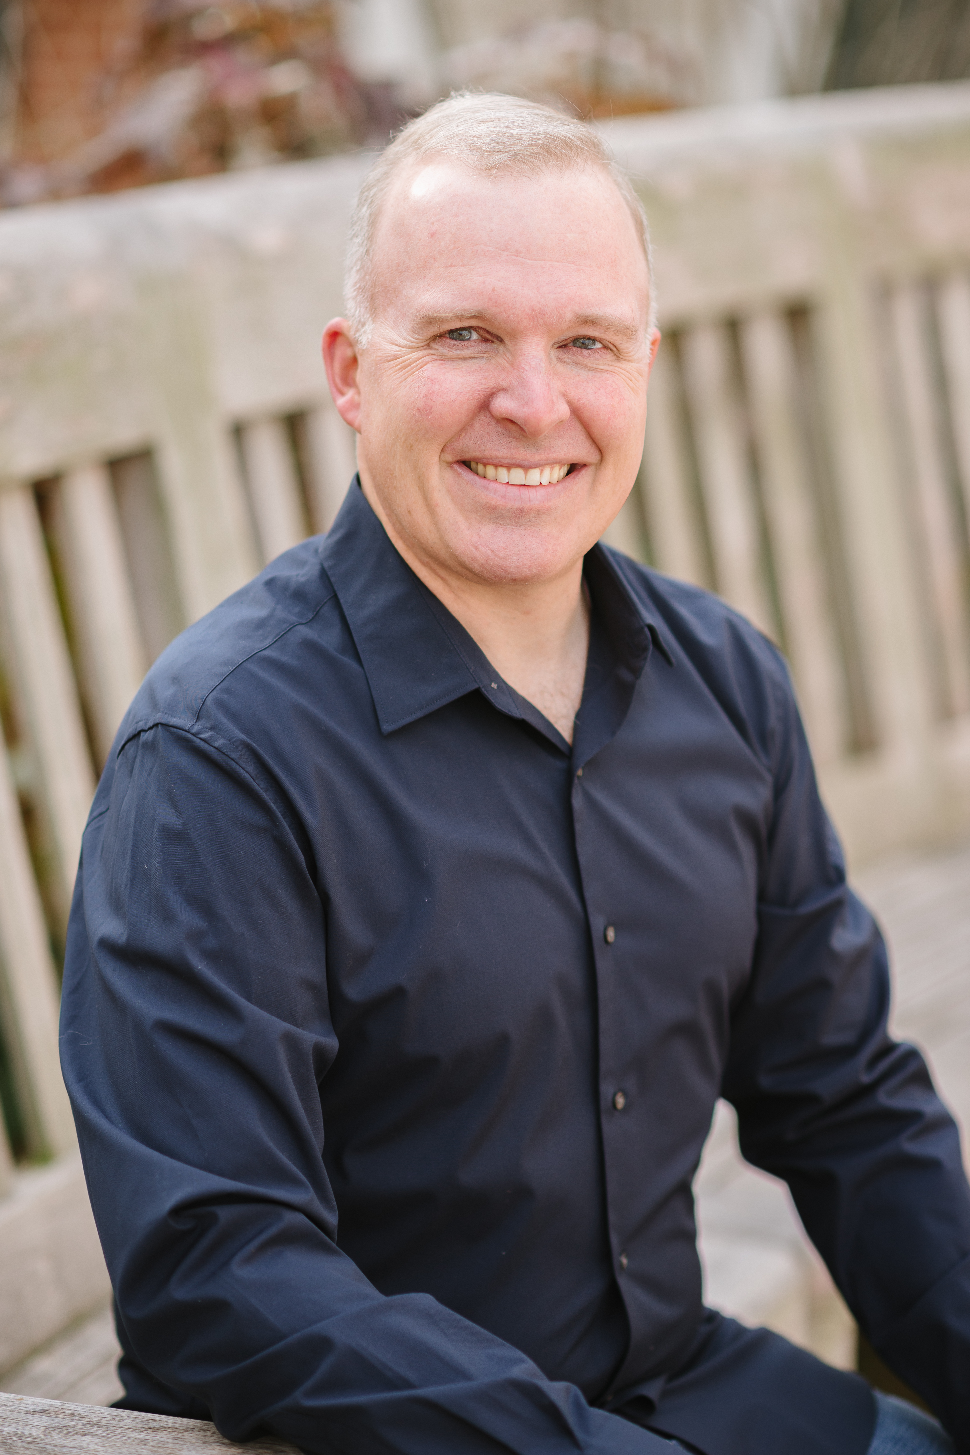
VETS AT EASE
MICHAEL A. COE, ACC, MS

Creating a world where all Veterans have a fulfilling life by connecting with their purpose, passion, and play.

Having retired from the US Air Force as a Lieutenant Colonel after a 22-year career, Mike knows first-hand that the transition to civilian life brings both opportunities and challenges. With Vets At Ease, Mike serves those who are about to or have made that transition and find themselves wanting additional support, direction, and focus in discovering and living into what’s next. Mike found the military’s Transition Assistance Program provided only a small fraction of the tools required to thrive in the post-military world, so he tapped into his mindfulness, martial arts, movement, storytelling, affinity for nature, and improv skills to successfully navigate the transition to civilian life. As a coach he uses these same principles with clients to co-create individualized practices and experiences to make lasting change.

In his own words: Transitions are like stomach aches - we all have them, we don’t talk about them, and most of us don’t ask for help until we’re doubled over in pain. I’m a guy who went through some shit (PTS(D), anxiety depression, addictions, asking what do I do now?)), figured some things out, and developed expertise so I can pass along what I’ve learned to others. I am a holistic coach and work with the heart, mind, body, and soul. With my extensive leadership and improv backgrounds, my coaching is a unique blend of serious leadership and playful creativity. You can expect to improve resilience, have more ease in life, and explore meaningful questions like “what is the life I want, and how do I get there,” while acquiring practical skills to use immediately. I work with clients who are homeless to CEOs, focusing on those that are willing to do the work. Coaching may be challenging at times...and it doesn’t have to suck.

With over 10 years of leadership presence coaching, Mike is a graduate of the Georgetown University Leadership Coaching program and is an Associate Certified Coach with the International Coach Federation. He expanded his credentials becoming both a Master Somatic Coach with the Strozzi Institute and a Master Leadership Embodiment Coach. Mike has completed two improv training programs and has two master’s degrees in Strategy and Project Management. He’s currently pursuing a PhD in East-West Psychology.

An avid runner, swimmer, and backpacker, Mike’s bag is full of snacks, a mind-bending book, and his journal. His nephews have ranked him the #1 Uncle Mike (of 1) for 9 years straight. As a Minister with the Universal Life Church and a naturalized citizen of Hawaii, he infuses his life with Aloha. Mike lives in San Francisco and rides his bike everywhere.

